

**PROJECT REPORT**

**Theme: ”Restaurant – customers can submit orders for food in menu and books tables.”**

**“ALPHA Restaurant”**

**Fast and delicious**

**Group: ”Alpha”**

**Anora Sultonova U1810074**

**Riskiya Abrorova U1810018**

**Furqatjon Mirzajonov U1810034**

**Doniyor Kuchkarov U1810047**

**Rakhmatullo Rasulov U1810093**

**Sardorbek Rakhmonov U1810055**

https://github.com/iuthub/ip-group-project-alpha.git

**www.alpharestourant.uz**

**CONTENTS**

**SECTION 1:** **Abstract…………………………………………..**

**SECTION 2:** **Introduction……………………………………...**

**SECTION 3:** **Project Overview………………………………...**

**SECTION 4:** **Project Design & Implementation………………**

**SECTION 5:** **Conclusion………………………………………..**

**SECTION 6:** **References…………………………………………**

**SECTION 7:** **Project Team…………………………………….**

**PROBLEM STATEMENT**

Today, people adapt to the rhythm of the developing world and people do not always have time to cook themselves. Today, based on these problems, online orders are created. Another common problem is restaurant Seating, where people have to go to a restaurant and make a table reservation in case the restaurant is busy. On holiday days or weekends, restaurants are full of people and not everyone can find a place to eat. Based on this, we simplified the task - you can book a table online, which simplifies the problem of a person.

**ABSTRACT**

This system is intended for people with limited time. with this system, a person can make an order, find out about the restaurant, the menu, about products, and also book a table. The main purpose of developing this project is to manage the booking, it will save both clients` and staff`s time. It provides different types meals and products for clients with good price and with all necessary amenities for their comfort.

**INTRODUCTION**

With an accelerated pace of life, people do not always have time to monitor their nutrition. Because of the work that takes up more time or because of other things, people do not have time to prepare food at home. therefore, the demand for restaurants growing every day. from here, other problems begin to arise. a person can spend a lot of time looking for a good place to eat with good and quality food and service. On weekends, holidays or during lunch, restaurants are Packed with visitors and not everyone can find a place to eat and breaks all plans. This program is aimed at solving the above-mentioned tasks. our service provides people with a wide range of dishes with a reasonable price, with descriptions and pictures of the menu, the ability to order a dish to your taste and book a table.

**OVERALL PROJECT OVERVIEW :**

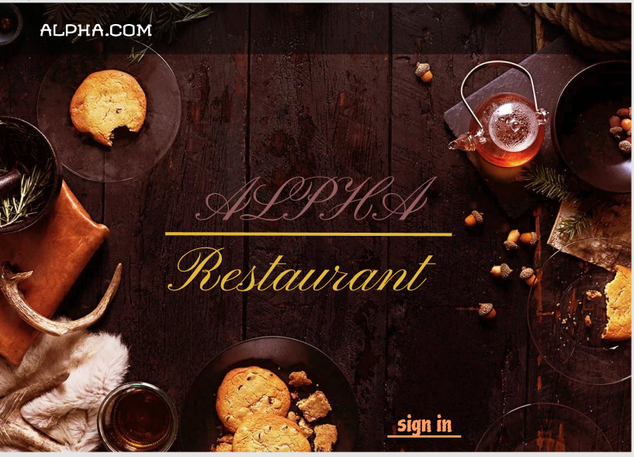

The first thing that clients see is this page, where client can understand that this application for restaurant with name “ALPHA”. Client can click “ALPHA.COM” and get overall information without registration:

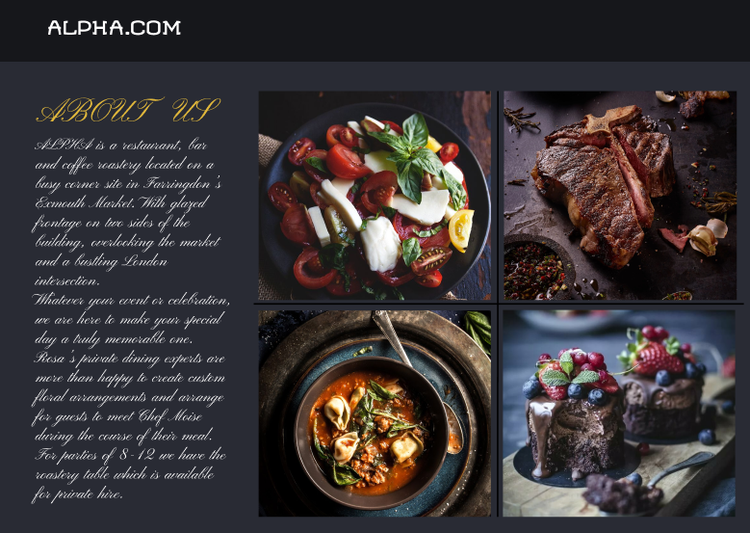

Or do registration press the “sign in” in right corner, which goes to the registration page.

Registration page. There are two page for sign in to application:

First you already registered and have account:

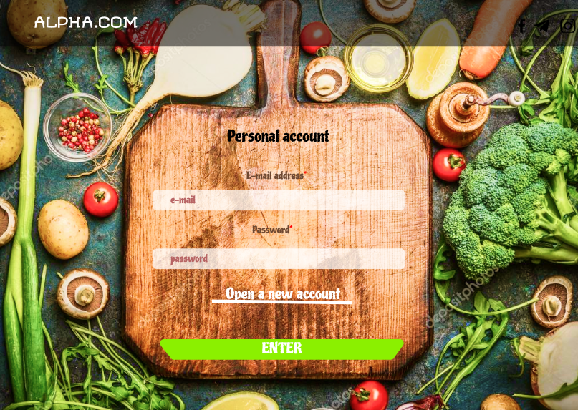

If not client can press the “Open a new account” and client can see next page where he/she can do registration:

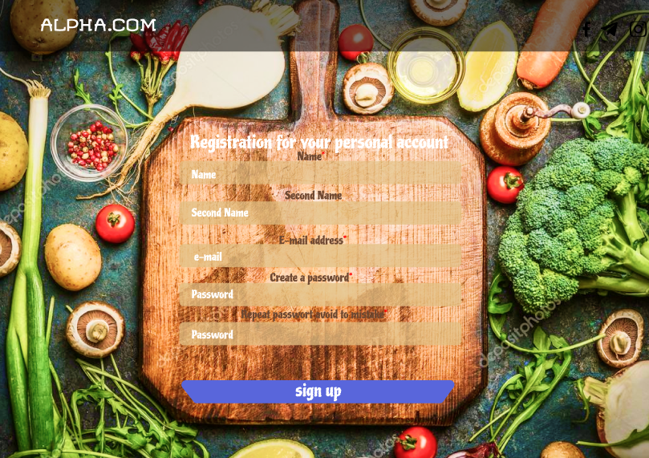

Here client can see page “Registration for your personal account” and list of empty spaces where person need to feel them with the appropriate information:

1. Name (compulsory)
2. Second name
3. E-mail address (compulsory)
4. Create password (compulsory)
5. Repeat the entered password (compulsory)

After feeling the information, if they are right, account will be create successfully then it goes to the main (Home) page:

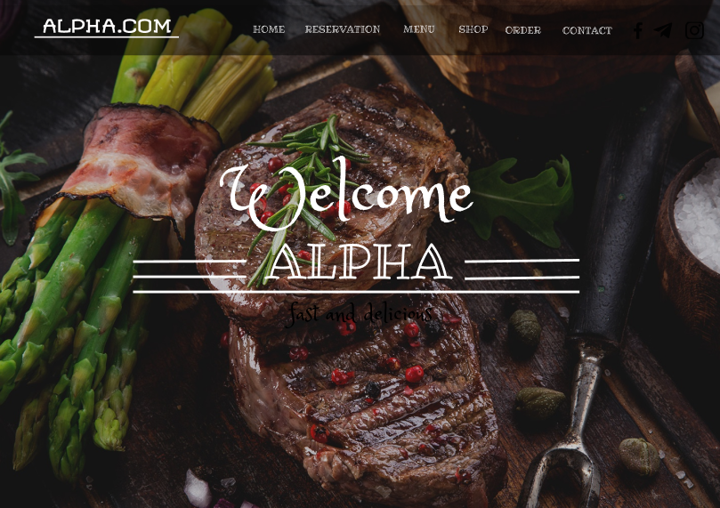

This is the main page, as you can see at the top menu:

-Home

-Reservation

-Menu

-Order

-Contact

RESERVATION. This page:

Here client can book online the table in this restaurant. For this client should write number of table, number of visitors, data when he will order and time of coming, after he/she have to write his phone number to contact then he/she can finish reservation service by pressing the button “BOOK”.

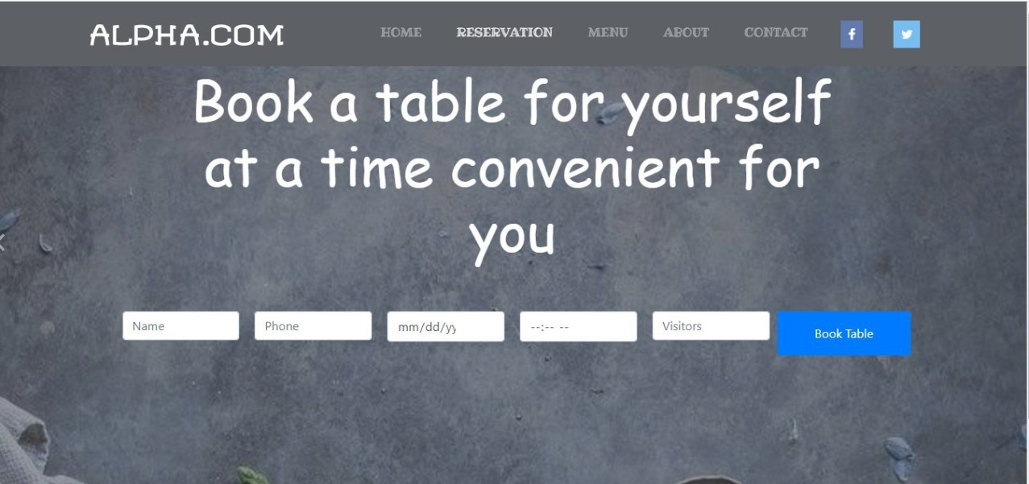

MENU. Menu page consist from the following:

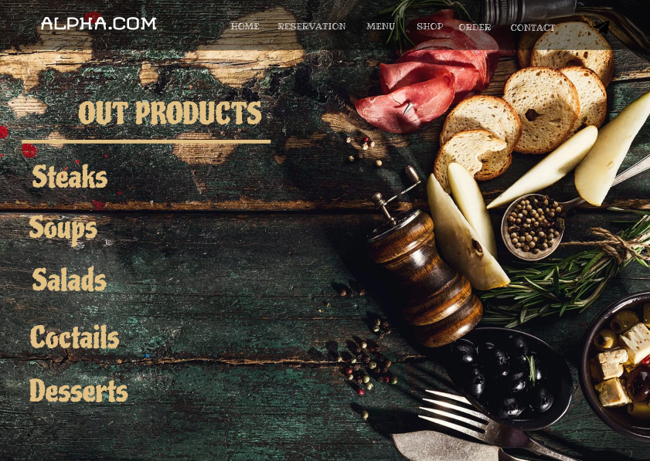

In “Menu” section client can see what meals are on the menu. Client can choose one of them and see more details. For instance the client choose “Steaks”:

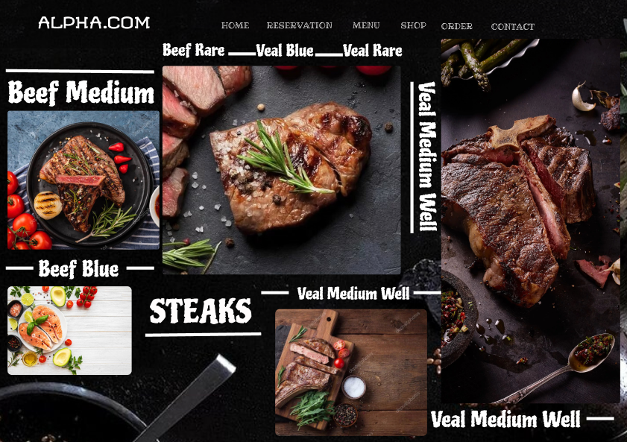

Here client can see what type of steaks here.

ORDER. In this section client can order the appropriate meal without looking into menu.

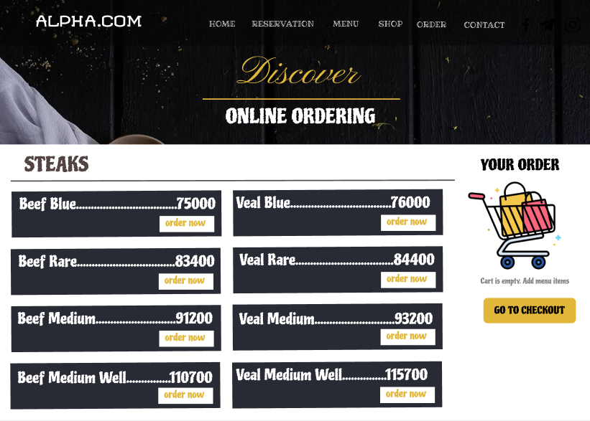

In left sight the list of meals by two columns with the price for 1 portion of dish. Client can choose one or more meals by press the button “order now” then the chosen meal goes to cart. After chosen client can check the purchases by passing the button “GO TO CHECKOUT” in right side which lead to the next page.

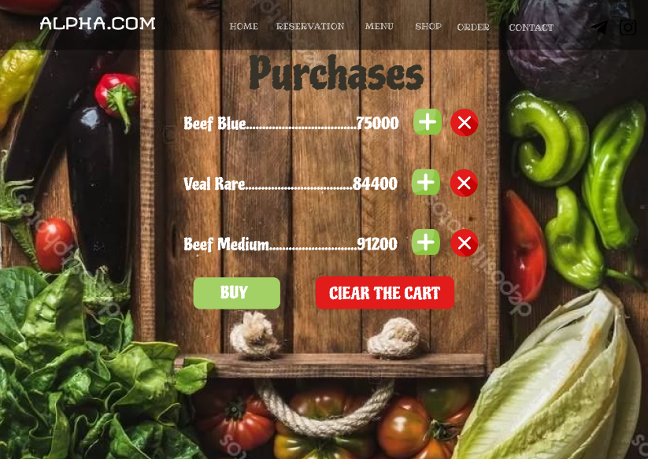

Here client see the chosen products with the prices. Additionally, he/she can modify the chosen meals, add portion or cancel the meal. There are two button “BUY” and “CLEAR THE CART”. The button “CLEAR THE CART” can remove all purchases and it follow the next page:

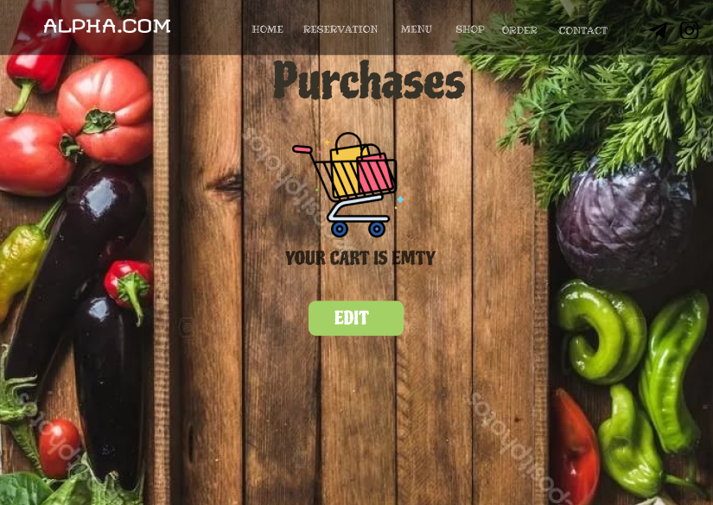

Here cart will be empty and client can edit cart from the start. If client press the button “EDIT” it will goes to “ORDER” where he/she can start online ordering.

If client press the button “BUY” in “CHECKOUT LIST” it will follow to this page:

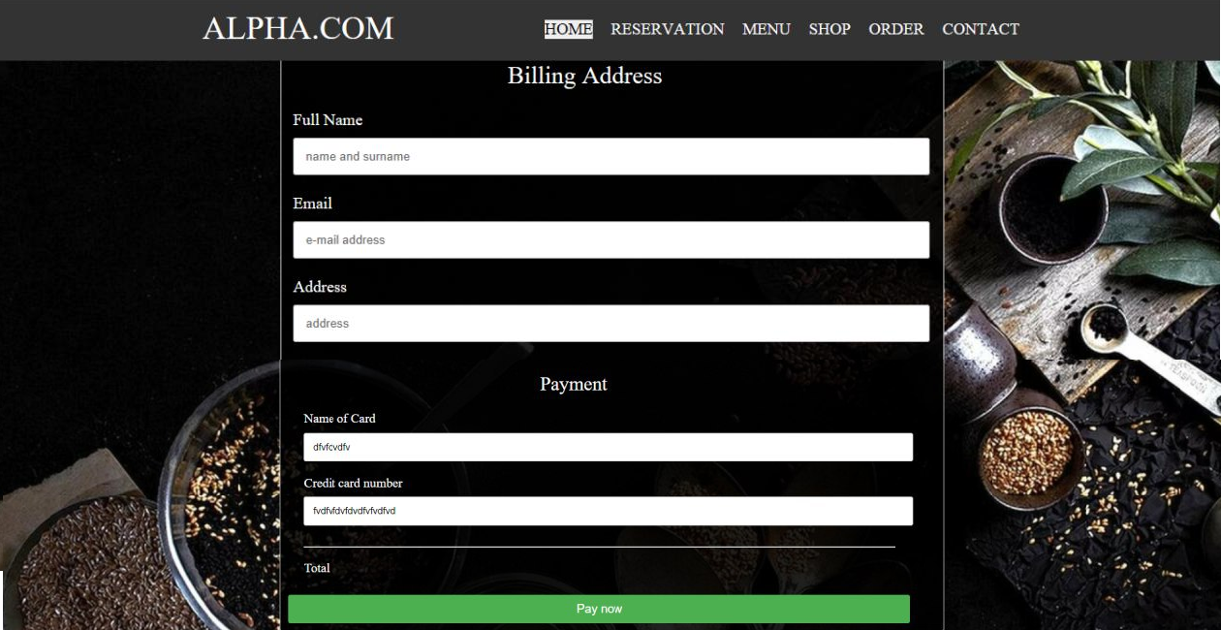

Here client have to feel the blank with his own information for finishing the order and click the button “Pay now”. After this action Admin get the information page:

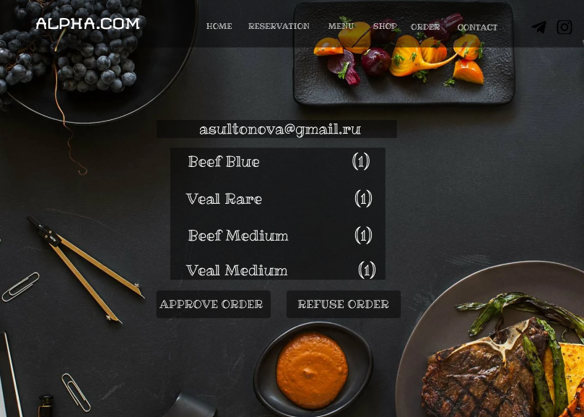

This page intended for admin where admin can see the order and decides approve order or refuse order. In both cases it will send the email message for the client with decision.

CONTACT. In Contact page:

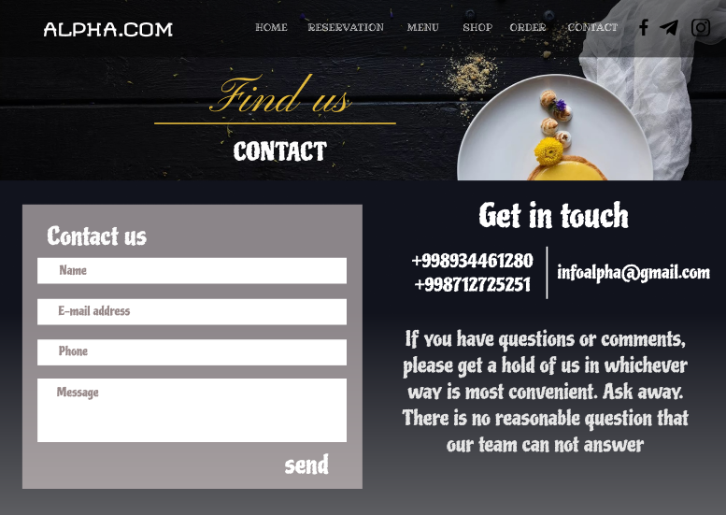

Here client can get the number of the restaurant or send the message. For this client should write name, email phone number and type the message. After sending the message staff will try to answer and send email message of the client.

* **Database Table Diagram**

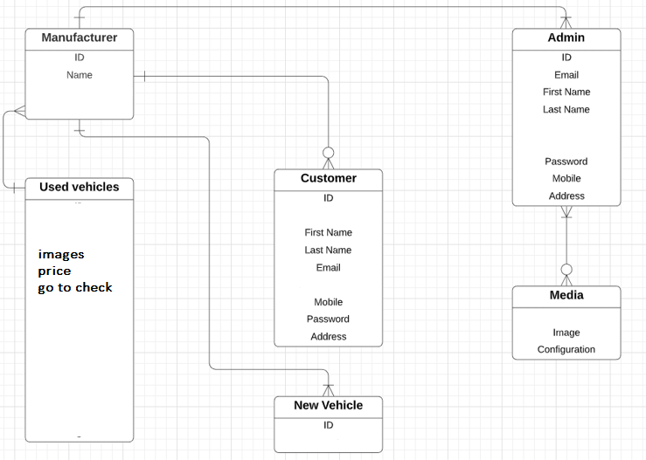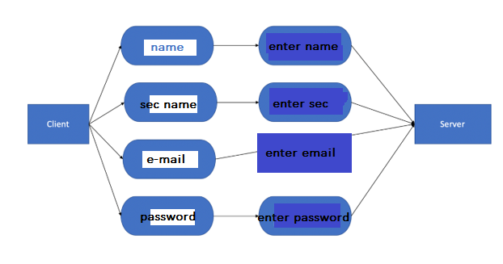

Products:

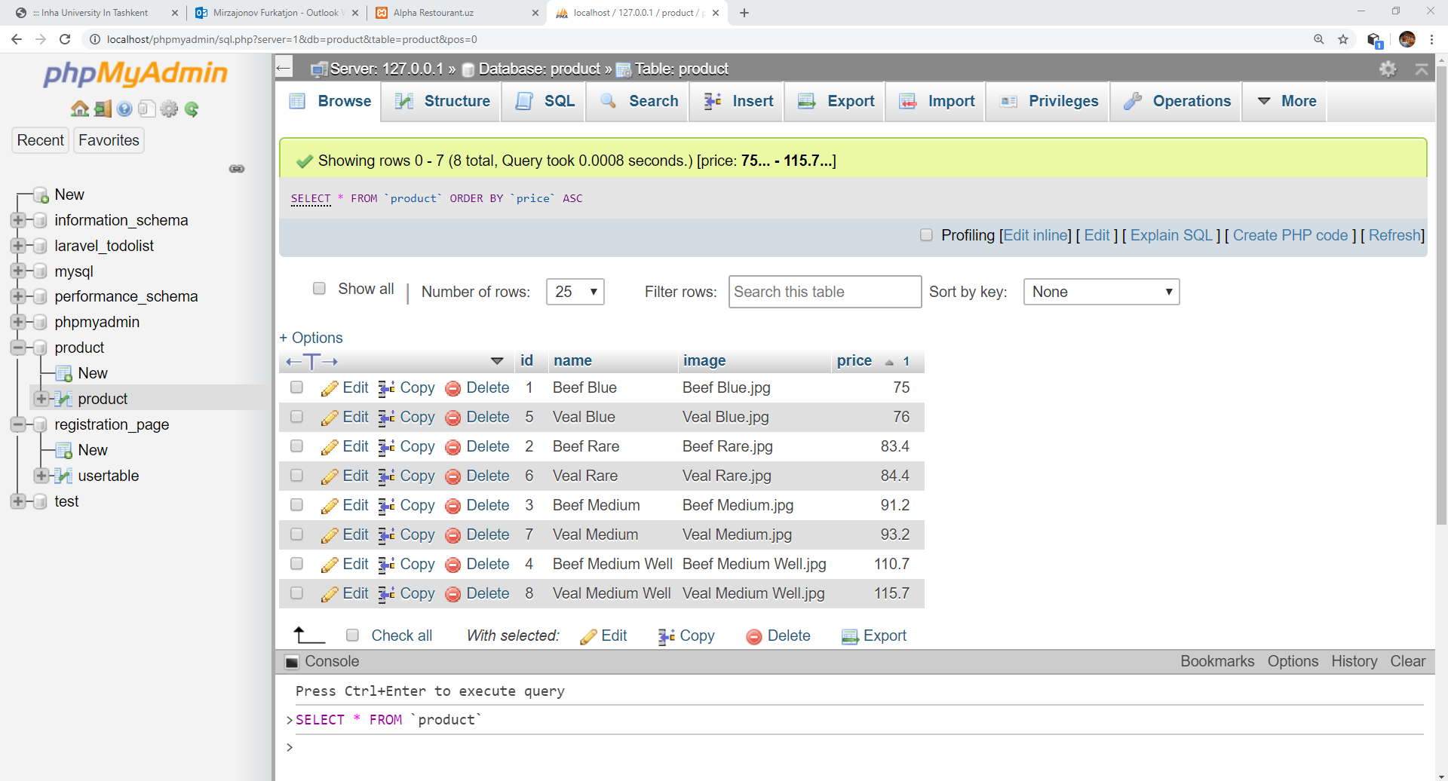

Database registration:

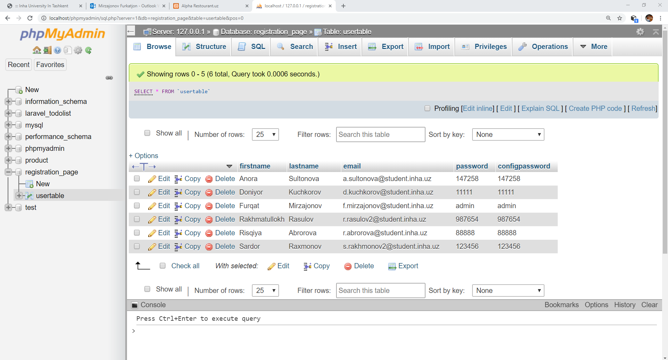

References:

<https://www.w3schools.com/>

http//getbootstrap.com

https://sigma.com